|  |  |  |
| --- | --- | --- |
| **cid:image007.png@01D2198C.095D21E0** | WEST SUSSEX COUNTY COUNCIL BARTONS PRIMARY SCHOOLHeadteacher: Mrs Kate Powell **Lethaby Road, Bognor Regis,**  **West Sussex PO21 5EJ**  **Tel no. (01243) 822056 Fax no. (01243) 841580**  **email: office@bartonsprimary.school** |  |



Tuesday 6th February 2018

Dear Parents,

Today is Safer Internet Day! All across the world, schools and businesses are playing their part. The children have been looking at the slogan:

‘Create, connect and share respect: A better internet starts with you!’

They have been learning about how to make positive choices online and to think about how others may react to the choices they make. How can you get involved? Ask your child what they have been doing today. Begin to have a conversation about their online habits and how much they know about protecting themselves when they go online. You can find more information on our website or access the websites listed below.

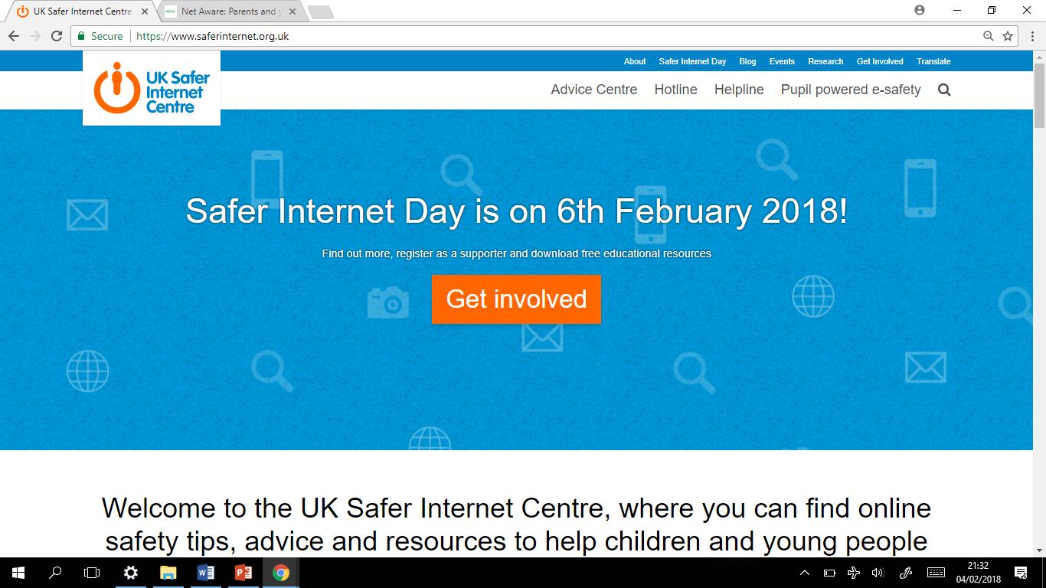



www.saferinternet.org.uk/

www.childnet.com



www.net-aware.org.uk

www.thinkuknow.co.uk

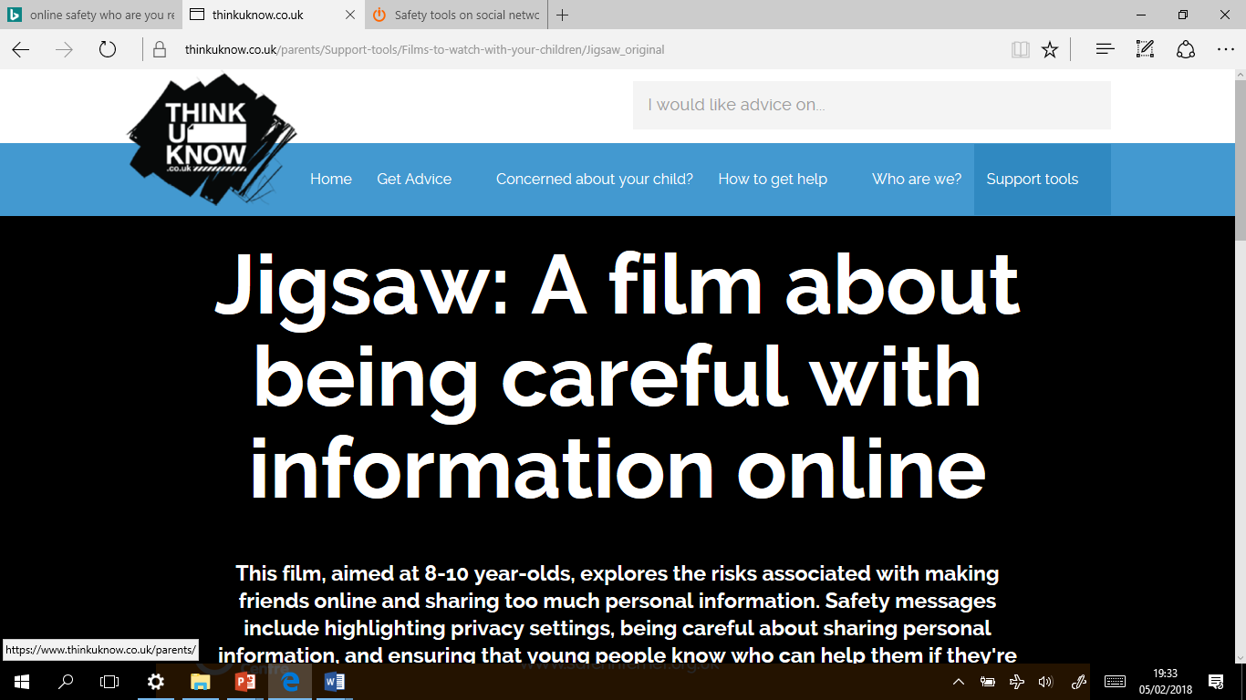

Many Thanks

Miss De Silva

Computing Coordinator