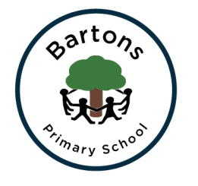
Year 2 Newsletter
Spring 2020

Welcome back to another exciting term at Bartons; hopefully you all had a wonderful Christmas break. The children have quickly settled back into our routines and are ready and raring to go with their new learning. PE will now take place on Mondays and Wednesdays.

Topic
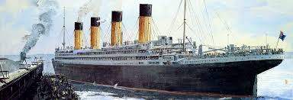
This term our topic is split into two parts. First half term our topic is ‘The Unsinkable’ where we will learn about the history of the Titanic and its tragic journey. All our wider curriculum and English work will be linked to it. We will be reading ‘Samson’s Titanic Journey’ in English to fully immerse ourselves into our topic. We will be visiting Southampton’s SeaCity Museum on Friday 31st January which the children and myself are very excited about.
After February half term we will be moving on to our ‘Frozen Kingdom’ topic where we will be learning about the North and South pole. This will link to our work in Science about living things and their habitats. In Geography we will also be looking at weather patterns and making comparisions for two different locations.

English
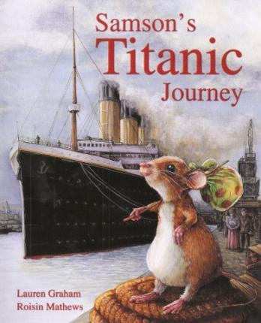
Our English work this half term is story writing, focusing on developing the middle of our stories. We will also be looking at writing a newspaper report on the Titanic as if we lived in 1912.
Alongside our writing we will be continuing to work on our grammar, spelling and phonics in order to prepare for the end of Year 2 SATS. We will also continue our hard work on handwriting which will be supported by daily activities.
Daily reading will also be vital for the children to reach the expected standards at the end of the year. It is therefore crucial that all children have their reading books in their book bags every day. This will be supported by whole class guided reading sessions where we will be focusing on the different reading skills the children need to develop. I have put the reading skills cards on our class page on the website.

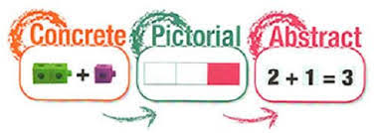
Maths
We are continuing to use the Numicon approach where we link the concrete, pictorial and abstract to ensure they understand the concepts we are learning. We are moving onto multiplication and division and will be completing more reasoning activities to apply our knowledge. We will continue to look at SATS styled questions.

SATS
As explained in the previous newsletter, in Year 2 the children have to take the ‘End of Key Stage SATS’ which will support the teacher assessment we will be completing throughout the year. The children will be assessed against the ‘Teacher Assessment Framework’ for Reading, Writing, Maths and Science. Thank you to all who could attend the meeting about SATS last week. Please remember I am happy to answer any questions.

Homework
Take Away Tasks will continue to be set every Friday and will be due in the following Wednesday, with our spelling test taking place on Thursdays. Three pieces of homework are set each week; spellings, maths and reading comprehension.

How can you help?
- Regular reading at home where you can share stories, asking and answering questions about what you have read.
- Ensure they have their school reading book in school every day as the children will be expected to read it after lunch, a time where those who are on Accelerated Reader can complete their quizzes.
- Encourage them to complete their homework tasks while letting them develop their independence.
- The children need to be at school promptly in the morning as they complete their Learn It’s and handwriting before guided reading at 9:05

Important dates:
Maths Workshop for Parents – Wednesday 15th January
English Workshop for Parents – Thursday 30th January
Titanic Museum Visit – Friday 31st January
Parents Sign Up sheets for Parents Evening – Monday 3rd February
World Book Day – Thursday 5th March
Sharing of work – Monday 16th March at 3:15
Tuesday 17th March at 8:45
Chestnut Class Assembly – Friday 20th March at 9:15

Any problems or questions please do not hesitate to come and see us.
Miss Grimsey and Mrs Cook

