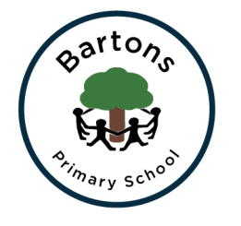
Year 2
Autumn Newsletter

Welcome back to another exciting year at Bartons; hopefully you all had a wonderful summer break. The children have settled well into our new room and are ready and raring to go with their new learning. We are very lucky to have Mrs Cook alongside myself and Miss Jewson ready to support them with all the work we have planned. Mrs Olliver will also be teaching the class every Monday.

Topic
This term our topic is split into two parts. First half term we are focusing on food and where it comes from. We may even get the chance to make some delicious meals. We are also currently trying to arrange a visit to a superstore but will let you know if this is possible.
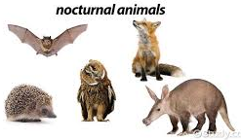
After half term our topic will be ‘Bump in the Night’ where we will learn about nocturnal animals, Tim Peake and the artist Susan Rothenburg. For more information about this term and the rest of the year you can find our Curriculum Overview on the class page on the school website.

English
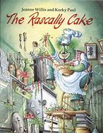
Our English work this half term is instruction writing, focused on recipes. After half term we will be looking at fairy tale stories with a twist, even getting the chance to write our own.
Alongside our writing we will be continuing to work on our grammar, spelling and phonics in order to prepare for the end of Year 2 SATS, more details to follow. We will also continue our hard work on handwriting which will be supported by daily activities.
Daily reading will also be vital for the children to reach the expected standards at the end of the year. This will be supported by regular group and whole class reading sessions where we will be focusing on the different reading skills the children need to develop.

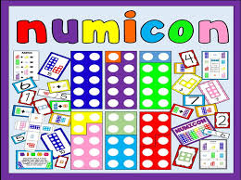
Maths
We are continuing to follow the Numicon approach which the children are now experts in! This half term we will be securing the skills we learnt in Year 1 before developing them further when exploring the Year 2 objectives. These include further strategies for addition and subtraction, while introducing multiplication and division. We will also develop our understanding of money, time and fractions. These skills will be supported by our Learn It’s where we will develop our fluency and recall of mathematical facts.
SATS
In year 2 the children have to take the ‘End of Key Stage SATS’ which will support the teacher assessment we will be completing throughout the year. The children will be assessed against the ‘Teacher Assessment Framework’ for Reading, Writing, Maths and Science. We will be having a meeting in the Spring Term to discuss this further, but if you wish to find out more information you can look at this website https://www.gov.uk/government/publications/key-stage-1-and-2-national-curriculum-tests-information-for-parents .

Homework
Take Away Tasks will continue to be set every Friday and will be due in the following Friday. However, the children will be able to hand in their book during any point in the week. We will continue to have the same format of having different tasks for you to choose alongside at least one that will have to be completed. The children who do not have their homework book in school on the Friday with the work completed to a satisfactory level will have to miss some or all of their Golden Time to do it.

How can you help?
- Regular reading at home where you can share stories, asking and answering questions about what you have read.
- Ensure they have their school reading book in school every day as the children will be expected to read it after lunch, a time where those who are on Accelerated Reader can complete their quizzes.
- Encourage them to complete their homework tasks while letting them develop their independence.
- Check our class page on the website to discuss their learning further.
- We also have a great number of jumpers and cardigans without any names. Please ensure you name them as we do not have the time to search for them.
- The children need to be at school promptly in the morning as they complete their Learn It’s and handwriting before phonics at 9.05.

Important date:
CHESTNUT CLASS ASSEMBLY – Date change!
9:15am - 9:45am, Friday 9th November 2018
We would love to show you some of the work we have done about our Field to Fork topic so it would be great to see you there.

Hopefully we will keep you up to date with any events and you can always check the timetable in the classroom window.

Any problems or questions please do not hesitate to come and see us.
Year 2 Team

