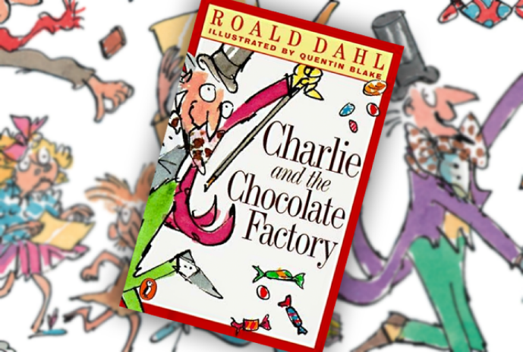

September 2017
Dear Parents,

I hope you have all enjoyed the summer break. It has been a pleasure getting to know the Year 3 children this week and looking forward to the rest of the term.

Our topic will be ‘Rainforests’. We will be also reading and studying the book Charlie and Chocolate Factory that will help us with our writing projects.

Reading to your child and listening to them read is still a very important part of their development. I realise it’s not always easy finding the time, but it does make a huge difference to their learning.

Children will receive homework every two weeks with a specific task to undertake and return. It will be handed out on a Friday. However, reading should be done as much as possible.

If you have any concerns or questions, I am usually outside the classroom in the mornings or after school.

Thank you for your support.

Mr Parsons Mrs Pett Mrs Terry

