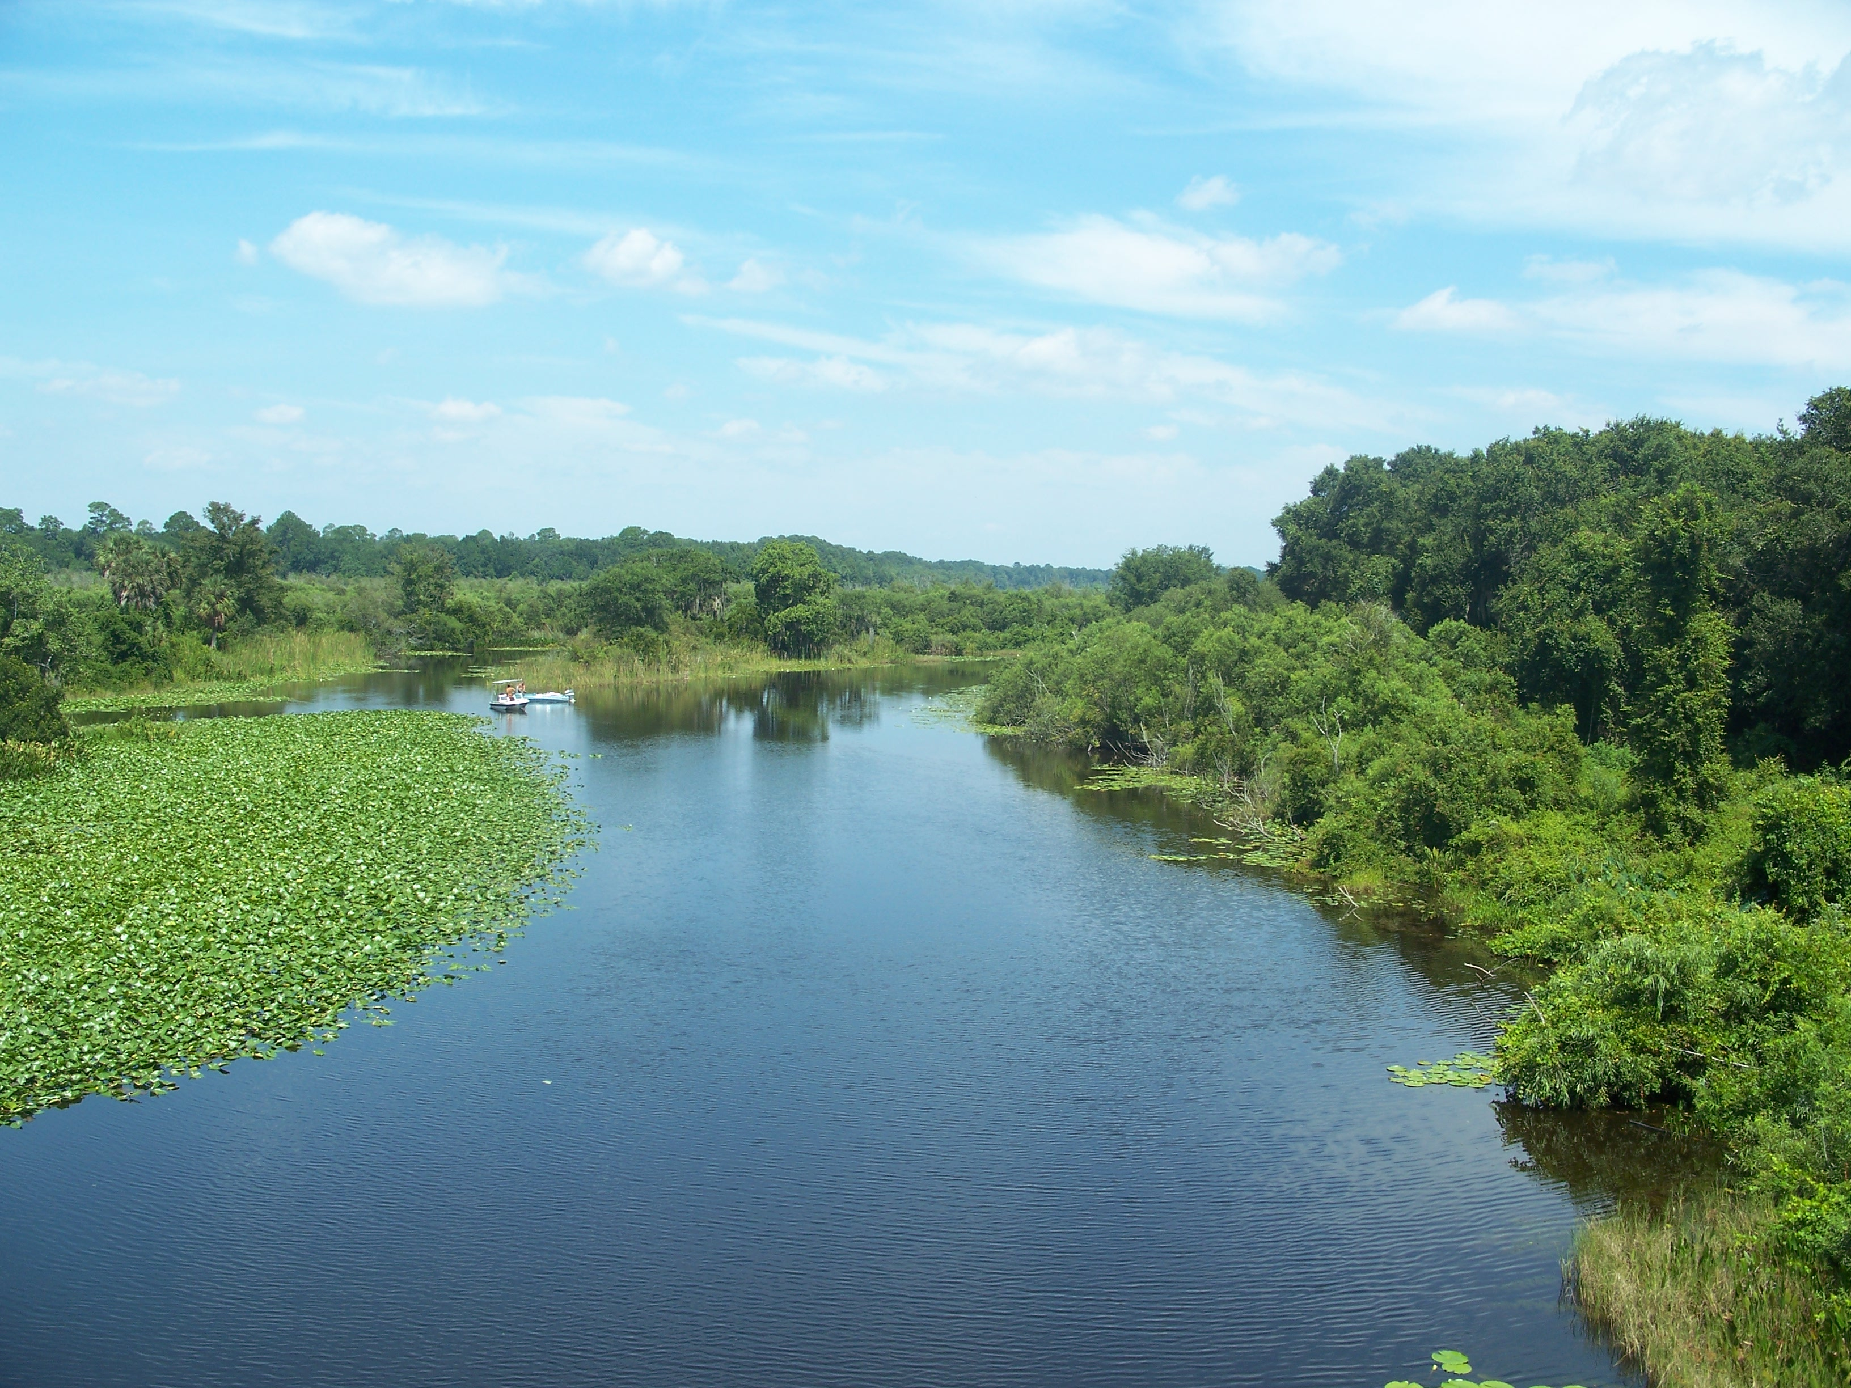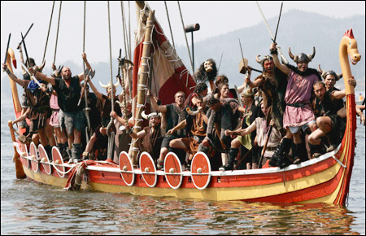Learning Journey
Year 4 – Summer Term 2018
Rivers and Vikings

Main Stimuli | Learning objective
Week 1 –  16.4.18  WWO & Maths Investigation Days!  Literacy – Launch | Literacy - LO: To create a spine poem.  Science – LO: To work scientifically investigating living things and their habitats.  Art – LO: To research Viking long boats and create pencil sketches.  Maths - To take part in a range of mathematical activities.
Week 2 –  23.4.18  Literacy – How to Train a Dragon | Science - To classify living things and their habitats.  Computing – Explore search engines.  Art – LO: To use watercolours to create stormy backgrounds.  Geography – To create a map of the local environment.
Week 3 –  30.4.18  Literacy – How to Train a Dragon | Science – To recognise changes in environments.  Geography – To understand the water cycle and the role of rivers.  Computing – Explore physical systems – Lego programme  DT – To research Viking longboats and create technical paper models. Annotate.
Week 4 –  7.5.18  Literacy – How to Train a Dragon | History - To know where the Vikings came from.  Computing – Explore physical systems – Lego programme  DT – Explore Viking cookery.  Art – LO: To improve mastery of clay and create Viking Gods.
Week 5 –  14.5.18  Literacy – How to Train a Dragon | DT – Design and innovate – Viking shoes.  Art - – LO: To improve mastery of clay and create Viking Gods.  History – - To know where the Vikings came from.  Computing –– Explore physical systems – Lego programme, create loops
Week 6-  21.5.18  Literacy – How to Train a Dragon | DT – Design and innovate – Viking shoes.  Computing –– Explore physical systems – Lego programme, create loops  History- To understand the beliefs of the Vikings.
Happy Half Term!

