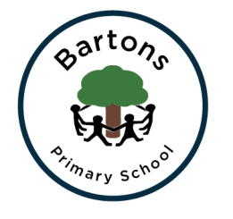 | WEST SUSSEX COUNTY COUNCIL  BARTONS PRIMARY SCHOOL Headteacher: Mrs Kate Powell  Lethaby Road, Bognor Regis, West Sussex PO21 5EJ  Tel no. (01243) 822056 Fax no. (01243) 841580  email: office@bartonsprimary.school

Dear Parents,
Welcome to Year 6! The term has got off to a flying start and the children have settled quickly.
Independence:
This half term our core value is independence and this is particularly relevant to Year 6 children in preparation for secondary school. Please encourage your child to pack their own bag the night before, remember to bring in their P.E kit on a weekly basis and take responsibility for their own homework.
P.E will be swimming on Wednesday and another session during the week, weather dependent.
Homework:
Homework will be set on Friday to be returned the following Thursday.
Homework may include grammar, punctuation and spelling, maths linked to the current learning and wider curriculum topic work. There is an expectation that the children will read at least 15 minutes per day at home and continue to practise their times tables.
Learning Journey:
Our learning journey for this term is survivors, there will be a learning journey on the class pages on the school website and on the classroom window.
Exciting news coming up, watch this space!
Keeping healthy:
Please remind your children to bring in their water bottle every day and a piece of fruit for break time.
Dates for Diary:
Thursday 27th September – Year 6 meeting 3.30pm in the hall Monday 1st October – Bikeabilty week starts Friday 5th October – Residential meeting 3.30pm in the hall
If you have any concerns please do not hesitate to speak to one of us.
Thank you for your on-going support.
Mr Hayne and Mrs Lewis

