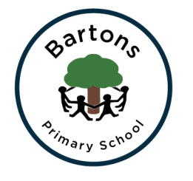 | WEST SUSSEX COUNTY COUNCIL  BARTONS PRIMARY SCHOOL Headteacher: Mrs Kate Powell  Lethaby Road, Bognor Regis, West Sussex PO21 5EJ Tel no. (01243) 822056  Fax no. (01243) 841580 email: office@bartonsprimary.school

Dear Parents,
Happy New Year! I hope you had an enjoyable and restful Christmas. This term our topic is ‘It’s a Mystery’. This is a scientific topic closely looking at properties of materials with a strong link to our class book: Varjak Paw. See the Learning Journey Plan on the school website for more information for Maths, English and Science.
PE
This term we will be learning how to play Ultimate Frisbee and improving our Striking and Fielding ability. Please make sure PE kits are in school all week. The PE kit must include tracksuit trousers, warm jumper and trainers as we will be going outside.
RE
This unit will look at ‘Jesus the Healer’. The children are learning about the Miracles and how Jesus healed the sick.
Art
This half term we will be studying the illustrator of Varjak Paw; Dave McKean. We will be looking at the style he draws in and trying to create our own character.
Computing
We will be re-visiting e-safety and covering areas such acceptable and unacceptable behaviours online and the importance of creating strong passwords. We will have a strong focus on social media and how to be safe whilst online.
Homework
This will continue to be given on a Friday and returned the following Thursday. Homework is important as it supports the learning in school and needs to be given priority. Please ensure you are continuing to practise times tables as these are the key foundations to a lot of Maths topics being covered this year. Children are allowed to read to themselves and record in their own diaries if they wish, but please question them on what they have read – use the question sheets in the homework books.
Any questions or concerns please see your child’s class teacher.
Many thanks for your on-going support,
Mrs Lewis & Mrs Calton

