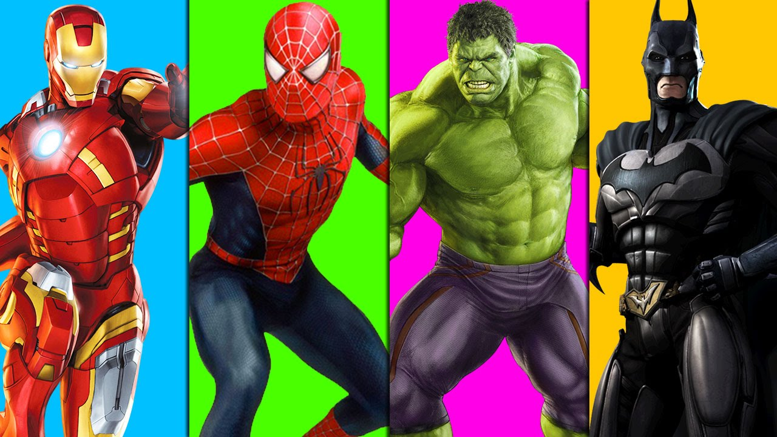
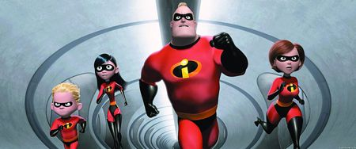
Superheroes

Learning Journey Year 1 Autumn 17
Main Stimulus | Learning Objectives | Context/Learning outcomes
Week 1  What makes me super?  6.9.17 (3 days)  WWO | Science 4 & 5: We are learning to draw and label parts of our body and match the sense to the body part.  History 1: We are learning to link members of our own families with the past and present. | Science: Draw and label body parts and identify and use their senses.  History: Create a family tree.
Week 2  Poetry  11.9.17 | Geography 1: We are learning to find places on an aerial photograph.  RE 1: We are learning how to look after each other.  Music 1: We are learning to sing a song.  Computing 1: We are learning to use technology safely and respectfully. | Geography: Name and locate features on an aerial photograph.  RE: Draw ways to look after each other.  Music: Learn song Hey You!  Computing: How to log in and log off computers.
Week 3  Traction Man  18.9.17  Maths Investigation Day | Art 1: We are learning to use paint to share ideas, experiences and imagination.  RE 2: We are learning about the Hindu festival of Raksha Bandhan.  Music 2: We are learning to sing a song and play instrumental parts. | Art: Create painting of superheroes.  RE: Explain what the festival of Raksha Bandhan represents.  Music: Learn Hey You and play musical instruments.
Week 4  Character Description  25.9.17 | DT 1: We are learning to design a product and use a range of materials to make it.  RE 3: We are learning about a Christian bible story.  Music 3: We are learning to sing the song and improvise using voices and instruments.  Computing 2: We are learning to use technology to purposefully organise, store and retrieve digital content. | DT: Design and make a superhero cape.  RE: Explain the message of the Good Samaritan story.  Music: Learn Hey You and improvise.  Computing: Improve typing skills.
Week 5  Pop Art  2.10.17 | Art 3 & 4: We are learning to work in the style of an artist.  RE 4: We are learning what a Sikh Langar meal is.  Music 4: We are learning to sing the song and perform compositions.  Music 5: We are learning prepare for a performance. | Art: Create artwork inspired by Roy Lichtenstein.  RE: Draw a Langra meal.  Music: Perform compositions. Music: Rehearse performance.
Week 6  Superspoons!  9.10.17 | DT 3: We are learning to design a product and use a range of materials to make it.  Computing 5: We are learning to understand what computer programs are.  RE 5: We are learning about the Islam story Be My Guest.  Music 6: We are learning to perform a piece of music.  Computing 3: We are learning to use technology to purposefully create and manipulate digital content. | DT: Design and make a superspoon.  Computing: Superspoon instruction algorithm.  RE: Explain the message behind the story.  Music: Perform piece of music.  Computing: Insert picture and type a sentence.
Week 7  16.10.17  Science - Light | Science 1: We are learning to find different sources of light.  Science 2: We are learning how shadows are made.  Science 3: We are learning to ask questions that have more than one answer.  Art 2: We are learning to use drawing to share ideas, experience and imagination.  RE 6: We are learning about the Buddhist story Monkey King. | Science: Identify sources of light.  Science: Learn how to make and change shadows  Science: Complete a shadow investigation.  Art: Create artwork focusing on shadows.  RE: Explain the different points of view in the story.
Half Term

