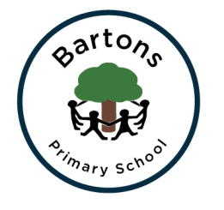
Year 3
Spring Newsletter

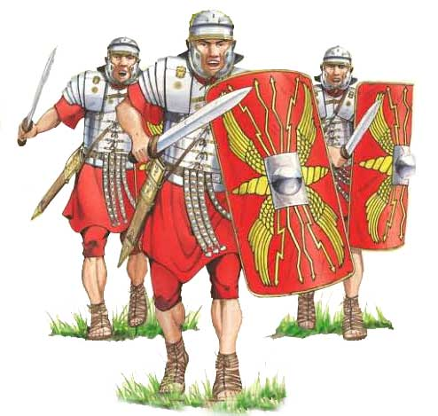
Topic
Our Spring Term topic is ‘The Romans’. This half term we are looking at the book ‘Escape from Pompeii’. We will be creating art work inspired mosaics. We will be getting a lot of inspiration from our Fishbourne Roman Palace trip. We will also be looking at volcanos and talking about different countries, with a particular focus on Rome. After Half term we will look at ‘Interesting Italy’ with a focus on the artist Antonio Sicurezza and create our own still life artwork. In History we will be learning about the history of Rome and the colosseum. For more information, you can find our learning journey on the class page on the school website. You can also see the learning for the rest of the year on the Year 3 curriculum page.

English
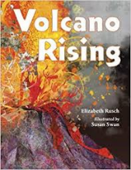
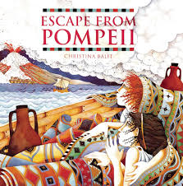
Our English work this half term is focused on writing a portal story, starting by reading ‘Escape from Pompeii’. The children will be looking at the structure of a story focussing on using inverted commas correctly and writing their own portal story. After half term our book will continue, but we will also look at Alongside our writing we will be continuing to work on our spellings, continuing our spelling scheme where we have a spelling pattern to learn each week. Handwriting and Spell it activities will take place every morning to ensure progress is continuing.

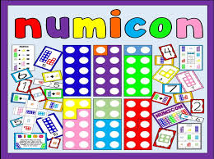
Maths
We are continuing to follow the Numicon approach which the children, they have loved exploring with all the different equipment and are constantly showing me their confidence as they are experimenting with different equipment. We will be introducing division as our first topic, we will then move onto money and numbers up to 1000.

Homework
Take Away Tasks will be still be set every Thursday and will be due in the following Thursday. The children can earn house points for completing the activities set which may include Maths, English or topic work linked to our learning. I would love for the children to continue with their daily reading and spelling practise to ensure lots of raffle tickets are collected.

Show and Tell
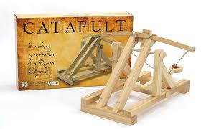
I will continue to encourage show and tell that is related to our topic. Children are allowed to bring in one piece of show and tell a week.

How can you help?
- Regular reading at home (not just their school book) sharing stories and asking and answering questions about what you have read. We usually link the homework to the skill we are assessing that half term so any support you can give will benefit your child.
- Supporting homework tasks while letting them develop their independence. Most children are completing their homework on time, however there are still some late arrivals of homework. The more they do at home the more confident they can be with their work at school.
- Encourage the children to use their neat joined handwriting when they are writing, especially with their homework.

Important dates:
Fishbourne Roman palace trip.
Thursday 7th February
As part of their Roman topic for this term, the children will be visiting Fishbourne Roman Palace on Thursday 7th February.

The Big Sing
Thursday 14th March
Our class have been lucky enough to be chosen to take part in this years ‘Big Sing’ this will be a day out at the Regis school, coming together with other primary schools to demonstrate our singing skills.

HAZEL CLASS ASSEMBLY
Thursday 28th March 9:15am
We would love to show you some of the work we have done this term, please come along if you can.

Hopefully we will keep you up to date with any events and you can always check the classroom window.

Any problems or questions please do not hesitate to come and see us.
Miss Cook and Mrs Terry

