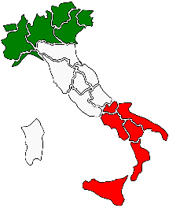
Year 3 Newsletter
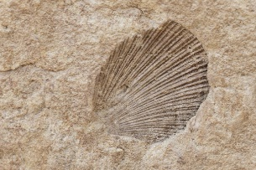
Welcome back to an action packed Spring Term, we hope you all enjoyed the Christmas break. The children have all come back full of enthusiasm for Volcanoes, Science week and fossil making. As you can see from the attached learning journey we have lots of learning ahead of us.
In Literacy we will be reading a story called Escape from Pompeii and working on our own portal stories where we travel back in time!
In Maths we will be using our Numicon equipment to help us visualise the processes we are developing and support mental methods for addition, subtraction and multiplication.
This half term we will be studying our ‘Interesting Italy’ topic in our Geography focus, looking at maps and the human and physical features of the country.
After half term we will start our ‘Rotten Romans’ topic where we will focus on History. We will also be visiting Fishbourne Roman Palace on Friday 23rd February.
This week we will be researching and tasting pizza ingredients and making our own pizzas. (We have an allergy list in school but please make sure I know about any allergies!)
Please read regularly at home ready to complete the Accelerated Reader quizzes and revise the spellings in your reading records. I will be sending home a homework activity each week. Over half term I will be asking you to make Roman shields (details to follow) for an activity next half term.
We are looking forward to all the exciting learning for this term. Any questions or problems please pop in to see us. Many thanks for your support.
The Year 3 Team

