Interesting Italy
Learning Journey Year 3 Spring 2018
Main Stimulus | Learning Objectives | Learning Outcomes
Week 1 (2 days)  What do we want to learn about Italy?  WWO day | Working with others  Volcano making  Art We are learning about a great artist from history, Leonardo da Vinci & using our sketchbooks to record observations. | Better communication, listening and eye contact.  Art Create artwork in the style of Leonardo da Vinci
Week 2  Rocks and fossils  Where in the world?  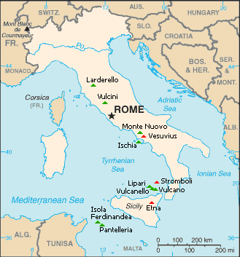 | Science We are learning to compare different types of rocks We are learning to make systematic & careful observations. We are learning to group rocks based on their properties. We are learning how fossils are formed  Geography We are learning to locate countries and cities using maps and atlases. We are learning to describe some of the physical geography of Italy.  Art. We are learning about a great artist from history, Leonardo da Vinci & using our sketchbooks to record observations.  Music Three little birds Bob Marley  French Classroom instructions | Science Discuss igneous, sedimentary and metamorphic rock. Learn how fossils formed and make our own version.  Geography locate Italy and surrounding countries on maps, compare it to the UK  Art Create artwork in the style of Leonardo da Vinci
Week 3  Physical features Volcanoes  Pizza  Portal stories | Geography We are learning to describe some of the physical geography of Italy. (Volcanoes)  Art We are learning about a great artist from history, Michelangelo & using our sketchbooks to record observations.  DT Research and evaluate pizza ingredients. Make pizzas  Music Jammin’ Bob Marley  French My Body | Geography Describe volcanoes and name some famous Italian volcanoes  Art Create artwork in the style of Michelangelo  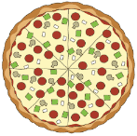  DT Eat pizza!
Week 4  Physical features Earthquakes  Portal stories | Science We are learning about Mary Anning & her contribution to palaeontology  Geography We are learning to describe some of the physical geography of Italy. (Earthquakes)  Art We are learning about a great artist from history, Modigliani & using our sketchbooks to record observations.  Music Small People Ziggy Marley  French Actions | Science Revise how fossils are formed and discuss a famous scientist’s contribution to palaeontology  Geography Describe earthquakes in Italy  Art Create artwork in the style of Modigliani
Week 5  Human features Venice and Pompeii  Portal stories | Science We are learning how soil is formed.  Geography We are learning to describe some of the human geography of Italy. (Settlements Venice & Pompeii)  Art We are learning to improve our mastery or drawing, painting and sculpture.  Music 54-46 Was my number by Toots & The Maytals  French Colours | Science Look at different types of soil and work on investigation and fair test skills  Geography Research two settlements and present their learning considering how physical geography meets human geography  Art Create artwork in the style of famous Italian artists
Week 6  Human features Leaning Tower of Pizza and the Colosseum  Shape poems  Half term homework | Geography We are learning to describe some of the human geography of Italy. (Structures Leaning Tower of Pisa and the Colosseum) Art We are learning to improve our mastery or drawing, painting and sculpture.  Music Our day will come by Amy Winehouse  DT Make a Roman shield | Geography Research two structures and present their learning  Art Create artwork in the style of famous Italian artists  More details to follow!

