 | Autumn 1 | Autumn 2 | Spring 1 | Spring 2 | Summer 1 |  | Summer 2
Topic | Stig of the Dump  (Portal Story)  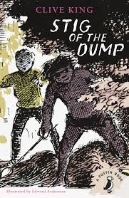 | 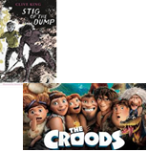  Stig of the Dump  Croods novelisation | Tudors  Henry the VIII    Character descriptions in Charlie and Chocolate Factory. | Shakespeare  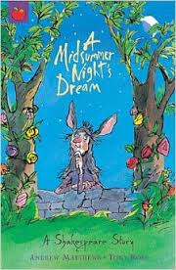  Midsummers night dream | 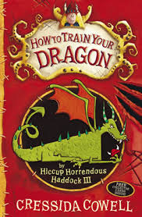  How to train your dragon |  | 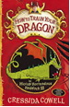How to train your dragon
English | Poetry –All about me spine | Poetry – Shelter spine | Poetry – Kennings & limericks | Poetry – Revisit kenning & limericks |   Poetry - Tell me a dragon  Free verse |  | Poetry – Spine poem
English | Genre:  Sequel - Barney and Stig meet 10 years later. | Genre:  Newspaper – Bartons archaeological dig. | Genre: Character description. | Genre:  Scripts | Genre:  Setting description, cave. |  | Genre:  Prequel – Backstory between dragons and parents.
Science | Electricity | Differences between solids, liquids and gases | Digestive system  Teeth | Sound | Living things and their habitats |  | Food chains
Computing | Scratch – creating algorithms  Online safety – social media | Scratch – creating algorithms  Digital images | Lego we do  Search Engines | Video uploads  green screen | Scratch – creating  Algorithms  Networks |  | Video uploads  green screen
History/ Geography | Stone age  Archaeology  timelines |  | Tudors  Tudor Life  Henry VIII  Shakespeare |  | Rivers | Vikings
Art/ Design Technology | Upcycling | Prehistoric art | Portraits | Making bread  Tudor buildings | Graphic Artist –Peter Hann  Bridge building |  | Seascapes  Constructing Viking long boats
PE | Gymnastics  Basketball | Hockey  Gymnastics | Dance  Team games (WWO) | Tag rugby  Dance -Tudor | Athletics  Badminton |  | Cricket  Sports Day
PSHCE | WWO/citizenship | WWO/citizenship | Physical activity and nutrition | Drug education | TBC |  | TBC
Core Values | Independence | Respect | Communication | Happiness | Responsibility |  | Creativity
RE | Christianity  Christmas  The bible |  | Food and fasting | People of faith  Easter | Buddhism  pilgrimages
Music | Key to music lessons with Drew Smith Turner

