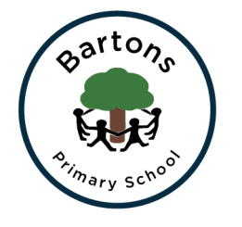
Year 3
Summer Newsletter

Topic
Our Summer Term topic is ‘The Stone Age’. This half term we are looking at two books, ‘UG The Stone Age Boy’. We will be creating art work inspired by cave paintings. History will be a vital part of this half terms learning. We will also be looking at Cave paintings, Stone Age food and homes. After Half term we will look at ‘Blue Planet’ a new topic I am incredibly excited about, focusing on sea pollution. With a focus on the artist Derek Gores we will create our own recycled art work, which will eventually be put up around the school grounds. We will also have a strong focus on DT creating items out of plastic bags. For more information, you can find our learning journey on the class page on the school website. You can also see the learning for the rest of the year on the Year 3 curriculum page.

English
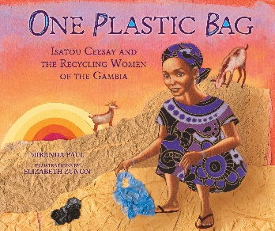
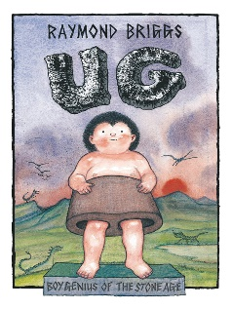
Our English work this half term is focused on writing a comic strip, starting by reading ‘UG’. The children will be looking at the structure of a comic strip focussing on using speech bubbles correctly and writing their own comic strip. After half term our book will change to ‘One Plastic Bag’ and our focus will be writing to inform. Alongside our writing we will be continuing to work on our spellings, our spelling scheme where we have a spelling pattern to learn each week. Handwriting and Spell it activities will take place every morning to ensure progress is successful.

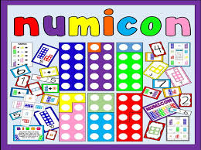
Maths
We are continuing to follow the Numicon approach which the children, they have loved exploring with all the different equipment and are constantly showing me their confidence as they are experimenting with different equipment. We will be introducing halving and doubling as our first topic, we will then revisit dividing but going deeper.

Homework
Take Away Tasks will still be set every Thursday and will be due in the following Thursday. The children can earn house points for completing the activities set which may include Maths, English or topic work linked to our learning. I would love for the children to continue with their daily reading and spelling practise to ensure lots of raffle tickets are collected.

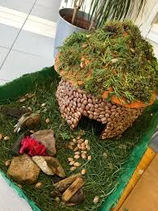
Show and Tell
I will continue to encourage show and tell that is related to our topic. Children are allowed to bring in one piece of show and tell a week.

How can you help?
- Regular reading at home (not just their school book) sharing stories and asking and answering questions about what you have read. We usually link the homework to the skill we are assessing that half term so any support you can give will benefit your child.
- Supporting homework tasks while letting them develop their independence. Most children are completing their homework on time, however there are still some late arrivals of homework. The more they do at home the more confident they can be with their work at school.
- Encourage the children to use their neat joined handwriting when they are writing, especially with their homework.

Important dates:
Monday 20th May – Outdoor learning day
Friday 24th – Film Night
Monday 10th June – Pollution awareness day (in class project)

HAZEL CLASS ASSEMBLY
Thursday 11th June 9:15am
We would love to show you some of the work we have done this term, please come along if you can.

Hopefully we will keep you up to date with any events and you can always check the classroom window.

Any problems or questions please do not hesitate to come and see us.
Miss Cook and Mrs Terry

