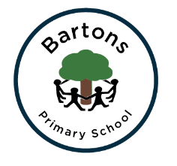Bartons Primary School

Consent Form

Please read and sign this consent form and return to school as soon as possible. The Home School Agreement must be returned to school separately.

Parents/Carers do have the right to not give permission for points 2, 3 and 4.

|  |  |
| --- | --- |
| Name of Child |  |
| Name of Parent/Carer |  |
| Date |  |

|  |  |
| --- | --- |
|  | Please sign each section to indicate your agreement or put a tick √ |
| **1. Code of Conduct/Home School Agreement**  I accept the Code of Conduct and the Home School Agreement. |  |
| **2.Internet Access**  I agree to my child using the Internet to access educational websites and email under supervision of the school. |  |
| **3.School Website**  I am happy for my child’s work to be put on the school website. |  |
| I am happy for my child’s photo to be put on the school website  (children’s names will not accompany the photographs) |  |
| **4.Press and Publicity**  I am happy for my child’s photo to appear in the press. |  |
| **5.Social Media Responsibilities**  I accept the Social Media Policy Advice (on the school website). |  |
| **6.Supervised Local Visits in and around Bartons Primary School**  I give permission for my child to make supervised local visits around the school. |  |
| **7.School Books at Home**  I accept responsibility for any school books brought home by my child. |  |

Thank you for your co-operation. The relationship between home and school is very important to us and it is vital that all of the school community work together to achieve the best outcomes for the all of the children.