Year 2 |  | Autumn 1 | Autumn 2 | Spring 1 | Spring 2 | Summer 1 | Summer 2
Writing Opportunities |  | 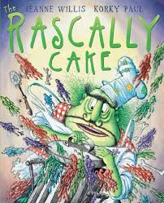  Rascally Cake | 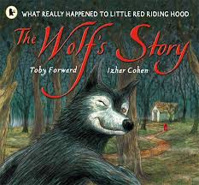  The Wolf’s Story | 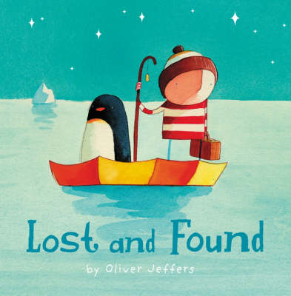  Lost and Found | 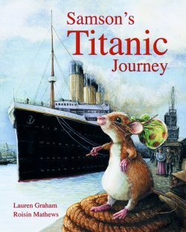  Samson’s Titanic Journey | 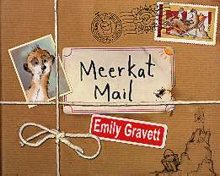  Meerkat Mail | 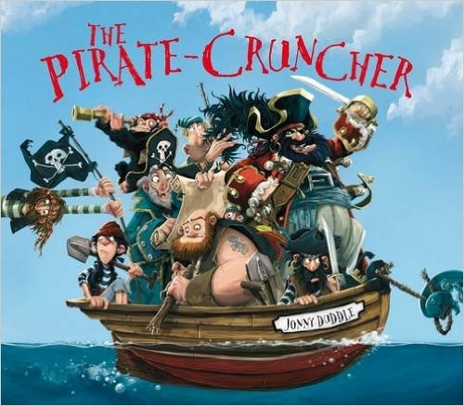  Pirate Cruncher
 |  | Poetry – (adjective adding) | Poetry – onomatopoeia, firework poems | Poetry – Shape poem (concrete) fire | Poetry – Cold… repetitive Shirley Hughes style. | Poetry – spine poem | Poetry – I was swimming one day and what did I see…  (alliteration)
 |  | Genre:  Instructions, | Genre:  Alternative Fairy tales, different view point. | Genre:  Sequel story. What happens next? | Genre:  Non Chronological Reports | Genre:  Journey stories | Genre:  How to catch a pirate
 |  | Free write – Fairy tales, | Free write – Letter to  Santa | Free write – instructions, how to build your house. | Free write –  Recount of Titanic museum visit | Free write – letters & postcards | Free write – Letter in bottle
 |  | Self-initiated | Self-initiated | Self-initiated | Self-initiated | Self-initiated | Self-initiated
Grammar Focus |  | Year 1 recap, capital letters, full stops, and exclamation marks.  Commas to separate lists  Sentence structure  - Statements & Commands  Correct past and present of the verb | Sentence structure - Exclamation (what/how)  Expanded Noun Phrases  Contractions (Nibbles) | Sentence structure – Question  Present and past tense  Subordination and coordination | All Sentence structures  Expanded Noun Phrases  Contractions | All Sentence structures  Possessive apostrophe | Revision of Year 2 grammar
Terminology |  | Noun  Verb  adjective  statement  command | Expanded Noun Phrase Adjectives & Adverbs exclamation  Question | suffix (pre-fix from y1)  question  tense (past, present) | apostrophe,  comma | Compound  contraction
Spelling | Wk 1 | kn & gn | /l/ spelt ‘le’ | adding –ed, -er, -est | /u/ spelt ‘o’ | – ment – ness - ful | homophones & near
Spelling | Wk 2 | wr | /l/ spelt ‘el’ | adding –ing | /ee/ spelt ‘-ey’ | - less & - ly | homophones & near
Spelling | Wk 3 | /s/ spelt ‘c’ | /l/ spelt ‘al’ & ‘il’ | –ing, -ed, -er, est | /o/ spelt ‘a’ | - tion | homophones & Conjunctions
Spelling | Wk 4 | dge/ge | /igh/ with ‘y’ | ing, ed, er, est, y | /er/ spelt ‘or’ ‘ar’ | Contractions | maths of the year /time
Spelling | Wk 5 | /j/ spelt ‘g’ & ‘j’ | adding – ies | /or/ spelt ‘a’ | /zh/ spelt ‘s’ | Possessive apostrophe | maths of the year /time
Spelling | Wk 6 | CE words | CE words | CE words | CE words | CE words | Question words SPaG terms
Spelling | Wk 7 | Review week | Review week | Review week | Review week | Review week | Review week
Reading Focus |  | Reading skill –  Imagining  Re-tell familiar fairy tales and poems | Reading skill –  Prediction  Predict what might happen on the basis of what has been read so far | Reading skill –  Inference  Making inferences on the basis of what is being said and done  Introduced to non-fiction books structures in different ways. | Reading skill –  Questioning  Ask and answer questions.  Check the text makes sense to them  Discussing the meaning of words | Reading skill –  Effect on the Reader  Recognise simple recurring language  Discuss favourite words and phrases | Reading skill –  Summarising  Discuss sequence of events in book and how they relate to each other.
Cross-curricular writing |  | DT Fruit Salad | Guy Fawkes  Christmas letters | Great Fire Pepys Diary | Titanic
Common Exception words |  | Who again  Class grass pass plant  path bath  water  door (pumpkin S) | Dark is…beautiful, kind  door floor poor (goldilocks)  Mr (Giant)  Father Christmas | cold gold hold told  people  great (fire) break steak | could should would  clothes, pretty door  whole (PbP) | again  water | Maths CE words:  half money hour past fast last  even any many whole
Other texts |  | Frog Belly Rat Bone The Tin Forest Pumpkin soup  Traditional Tales:  Red riding, Goldilocks, Jack | The Owl who was afraid of the Dark  A Wolfs Story  Who’s afraid of the big bad book? | Lost and Found  Oliver Jeffers Author study- Different stories by the same  author  Non-Fiction books  Great Fire of London | Non-Fiction books  I was there…Titanic  You wouldn’t want to sail on the Titanic | Meerkat Mail  Lila and the Secret of Rain  The Journey Home | Pirate Cruncher  Flotsam  Non-Fiction

