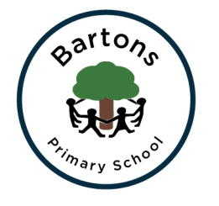
Year 1
Summer Newsletter

We welcome Miss Guppy to our class, a Student Teacher who will be helping us with lots of exciting learning over the Summer Term:

Topic
Our topic is ‘Who Lives Here?’ In Geography and History we will be learning all about houses and where people live. We will be going on a local walk to post a special letter and sketch different houses near the school. We will continue our amazing Music lessons with Mr Mott and will be working on striking and fielding skills with Mrs Barlow in PE. After half term our focus will be on animal habitats with our visit to Marwell Zoo. For more information you can find our learning journey on the class page on the school website.

English
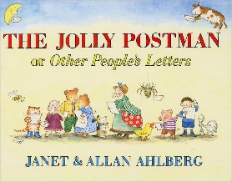
This week we were shocked to discover that the Gingerbread Man had broken into the classroom and had made a horrible mess! He wrote us a letter to apologise and explained he just wants a friend. We will be reading the Jolly Postman and writing letters to a variety of Fairy tale characters to help find him one. We also continue to work hard on our phonics in order to prepare for the Year 1 phonic test in June.

Maths
In Maths this term we will be learning about 3d shapes, the structure of 2 digit numbers and we will be working on our subtraction skills. We will also be learning to tell the time (using o’clock and half past) this term so lots of practice at home will really help the children.

Important dates:

Marwell visit Monday 17th June
Please arrive at 8:45 we will be leaving promptly at 9am! We will return to school at 4pm. If we are delayed we will send a text message so please ensure we have up to date contact numbers.

Beech Class assembly Thursday 27th June 9:15-9:30

Any problems or questions please do not hesitate to come and see us.
Mrs Morris, Mrs Shaw and Mrs Pett.

