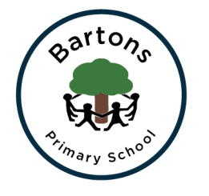 | WEST SUSSEX COUNTY COUNCIL  BARTONS PRIMARY SCHOOL Headteacher: Mrs Kate Powell  Lethaby Road, Bognor Regis,  West Sussex PO21 5EJ  Tel no. (01243) 822056 Fax no. (01243) 841580  email: office@bartons.w-sussex.sch.uk
6th January 2017
Dear Parents,
Happy New Year! I hope you had an enjoyable and restful Christmas. This term we will be learning about Ancient Egyptians. This is an exciting topic and I know the children will have a great half term. See Learning Journey Plan on the school website for more information.
PE
This term we will be taking part in team games and gym. Willow class are lucky to have a sports coach helping to support this learning. Please make sure PE kits are in school all week. The PE kit must include tracksuit trousers, warm jumper and trainers as we will be going outside.
RE
This unit will look at each religion’s view of peace. The children will compare and contrast the concept of peace across religions. Look at symbolic people of peace and well known symbols of peace before creating their own.
Art
This half term we will be improving our drawing skills particularly using pencil, pen and charcoal. We will be focusing on Egyptian portraits and making a mask in clay.
Computing
We will be re-visiting e-safety and covering areas such acceptable and unacceptable behaviours online and the importance of creating strong passwords. Also we will be using scratch online to create programs. Please make sure you have returned the Scratch permission letter.
Homework
This will continue to be given on a Friday and returned the following Thursday. Homework is important as it supports the learning in school and needs to be given priority. This term spelling patterns and activities will form part of the homework as well as Maths, Reading and Writing.
Any questions or concerns please see me.
Many thanks for your on-going support

Lynne Lewis

