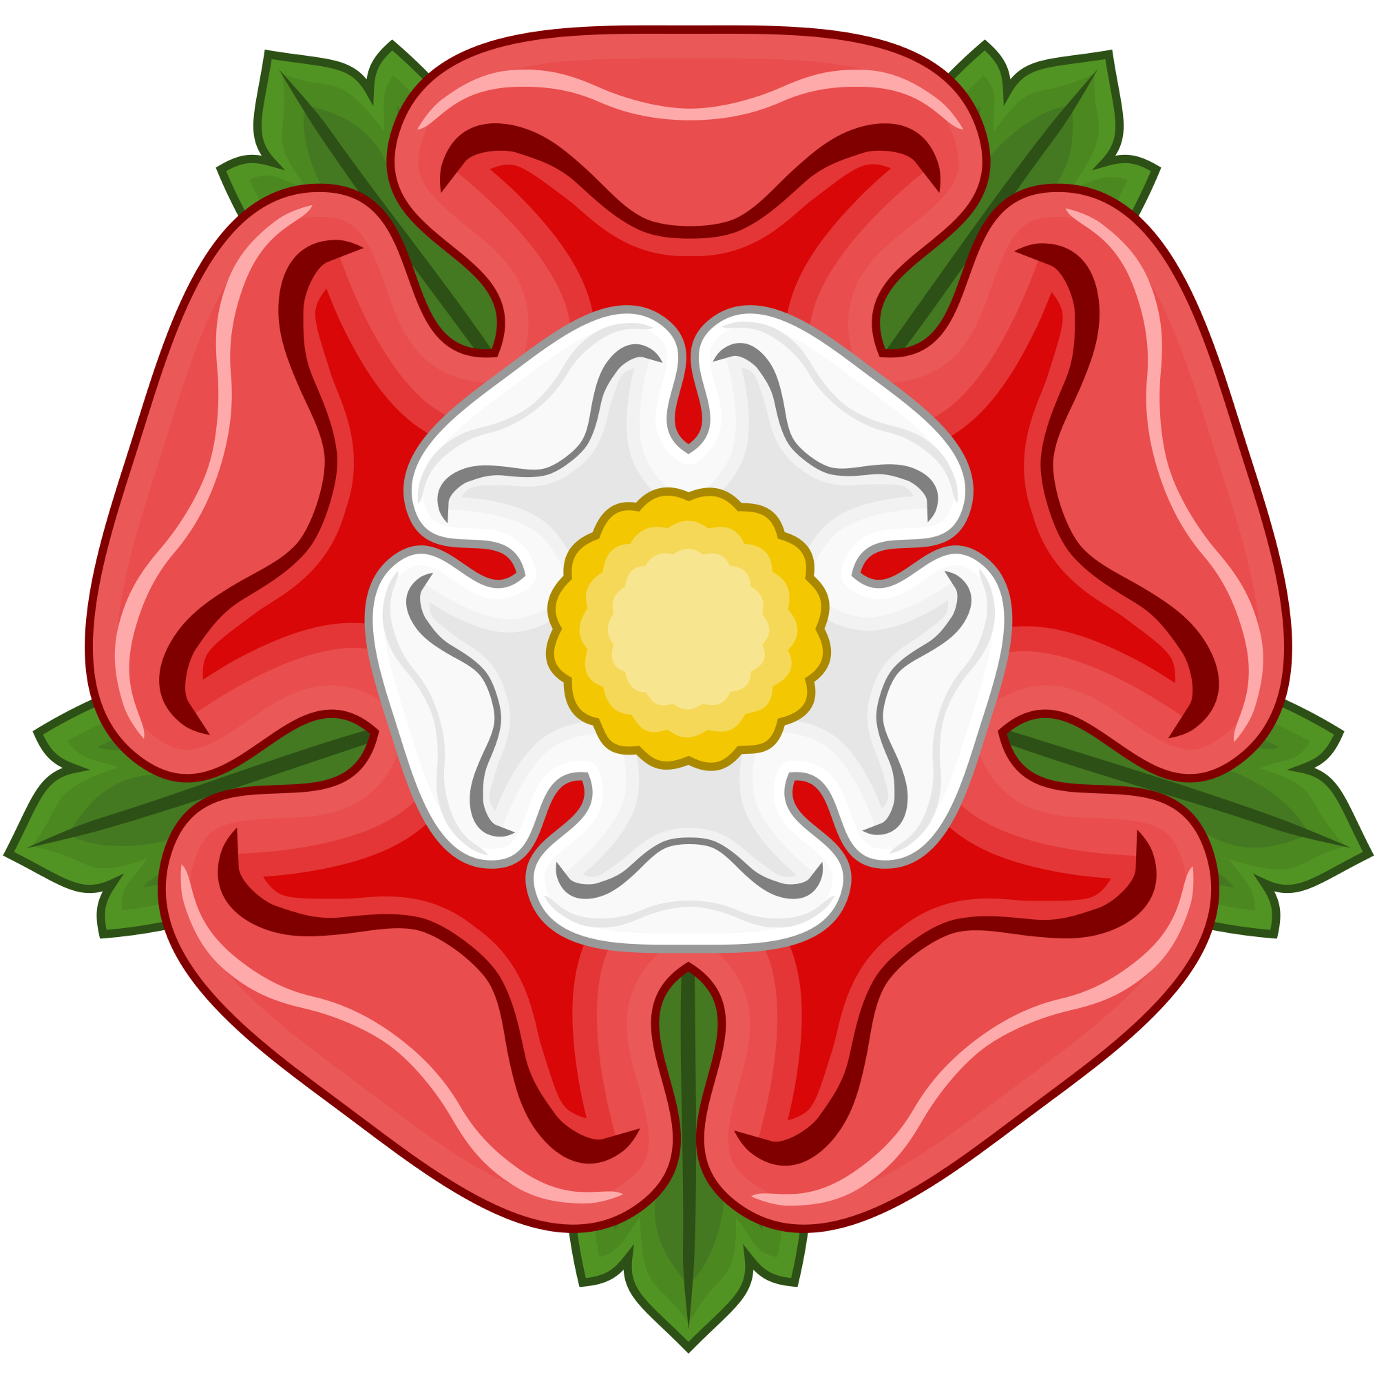Learning Journey
Year 4 – Spring Term 2018
Tudors

Main Stimuli | Learning objective | Learning outcomes/context
Week 1 –  4.1.18  (2 days)  WWO – Launch day  Tudor Poetry | WWO – To communicate effectively.  Literacy – To know the structure of a Limerick and Kenning. | WWO - To use positive body language and active listening skills.  Literacy – To write a Limerick and Kenning about the Tudors.
Week 2 –  8.1.18  Science Week!  Literacy – Do you want to be Henry VIII’s next wife? | Science – To know how the human digestive system works  Science - To describe the basic functions of the parts in the human digestive system  Science – To identify differences and similarities between teeth  Science – To work scientifically to create an enquiry  Science – To construct a variety of food chains and identify producers, predators and prey  PE – To identify key features of a dance  WWO/PSHE – To identify key aspects of sharing | Science - To label the human digestive system describe its functions and learn about teeth.  Science – To label and describe the functions using scientific language  Science – To compare teeth from  humans and animals  Science – To conduct an investigation about tooth decay  Science – To understand how a food chain works and use appropriate scientific language  PE – To practise a Tudor dance  WWO/PSHE – To know how to share and use appropriate language
Week 3 –  15.1.18  Literacy – Do you want to be Henry VIII’s next  wife? | History - To identify the result of a major historical event – Battle of Bosworth  Art – To study Tudor portraits  Literacy – To understand the key features of a character profile  RE – To know the key principles of Buddhism  PE – To reflect and improve Tudor dancing  D.T – To taste various breads  D.T – To research Tudor food | History - Write facts about the battle of Bosworth  Art – To create our own Tudor style portrait  Literacy – To create a dating profile  RE – To describe the key principles of Buddhism  PE – To reflect and give feedback  D.T – To understand Tudor ingredients  D.T – To compare different modern day breads and research the ingredients used in Tudor times
Week 4 –  22.1.18  Literacy – Do you want to be Henry VIII’s next wife? | History – To know why Henry VIII had so many wives  To use evidence to draw conclusions about Henry VIII  Literacy – To invent a dating profile for Henry VIII  Art - To study Tudor portraits  D.T – To follow a Tudor recipe to make bread | History – To know the purpose of the royal family  To research and gather evidence about Henry VIII  Literacy – To use the key features of a character profile  Art – To create our own Tudor style portrait  D.T – To make Tudor bread and review its taste
Week 5 –  29.1.18  Literacy – Battle of Bosworth Free Write | History – To know about how Tudor people lived.  Literacy – Write about Battle of Bosworth  Art – To develop techniques within drawing | History – To understand the difficulties of the rich and the poor during Tudor times  Art – To draw a skull onto a grid and then onto a distorted grid
Week 6 –  5.2.18  Creative Arts Day (thurs) | History – To know about how Tudor people lived  To understand what happened after Henry VIII’s death  Art – To develop techniques using a variety of media  D.T – To create a Tudor ‘Mini’ Village | History – To understand the role of the poor  To know the immediate history after Henry VIII’s death  Art – To develop Tudor stained glass  D.T – To review pros and cons of Tudor homes
 | Happy Half Term!

