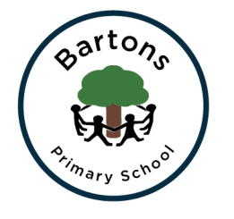 | WEST SUSSEX COUNTY COUNCIL  BARTONS PRIMARY SCHOOL Headteacher: Mrs Kate Powell  Lethaby Road, Bognor Regis,  West Sussex PO21 5EJ  Tel no. (01243) 822056 Fax no. (01243) 841580  email: office@bartons.w-sussex.sch.uk
24th April 2018
Dear Parents,
We hope you had an enjoyable and restful Easter. This half term we will be learning about Ancient Egyptians. This is an exciting topic and we know the children will have a great half term. See Learning Journey Plan on the school website for more information.
PE
This term we will be taking part in Athletics and Outdoor Adventurous Activity. Please make sure PE kits are in school all week.

RE
This unit will look at ‘forgiveness’. The children will be exploring and comparing ‘forgiveness’ in different religions. They will also be creating and explaining a symbol for forgiveness.

French
In the ‘That’s Tasty‘ unit, the children will learn key vocabulary linked to food and drink. They will learn specific vocabulary of how to say what drinks they like, what they like to eat for breakfast and fillings for sandwiches.

Music
The theme this half term is ‘The Fresh Prince of Bel Air’ We will be listening and performing a range of hip hop songs.

Homework
This will continue to be given on a Friday and returned the following Thursday. Homework is important as it supports the learning in school and needs to be given priority.

Date for your Diary
Year 5 invite you to their Ancient Egyptian Museum on Wednesday 16th May 2018 at 2.45pm.

Any questions or concerns please see your child’s class teacher.

Many thanks for your on-going support

Lynne Lewis and Kate Calton

