Year 4 |  | Autumn 1 | Autumn 2 | Spring 1 | Spring 2 | Summer 1 | Summer 2
Writing Opportunities |  | 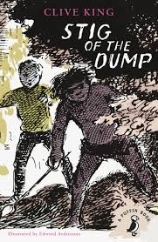  Stig of the Dump  (Portal Story) | 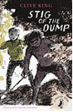  Stig of the Dump    Croods (novelisation) | Tudors  Henry the VIII  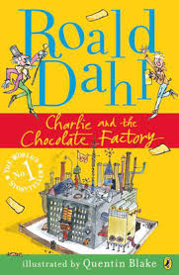  Character descriptions in Charlie and Chocolate Factory. | Shakespeare  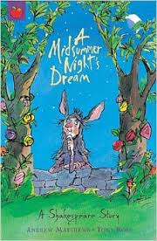  Midsummers night dream | 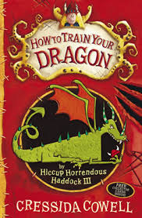  How to train your dragon | 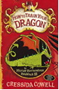  How to train your dragon
 |  | Poetry –All about me spine | Poetry – Shelter spine | Poetry – Kennings & limericks | Poetry – Revisit kenning & limericks | 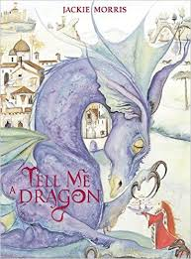  Poetry - Tell me a dragon  Free verse | Poetry – Spine poem
 |  | Genre:  Sequel - Barney and Stig meet 10 years later. | Genre:  Newspaper – Bartons archaeological dig. | Genre: Character description. | Genre:  Scripts | Genre:  Setting description, cave. | Genre:  Prequel – Backstory between dragons and parents.
 |  | Free write – upcycling information poster. | Free write – film review of the Croods. | Free write – Scene description Battle of Bosworth | Free write – Theatre review | Free write – grammar focus, based on interim. | Free write - Setting description, horror.
 |  | Self-initiated | Self-initiated | Self-initiated | Self-initiated | Self-initiated | Self – initiated
Grammar Focus |  | Year 3 revision  Inverted commas to punctuate direct speech.  Text structure – paragraphs, heading and subheadings  Sentence structure – conjunctions adverbs and prepositions.  Standard English forms for verb inflections instead of local spoken forms. | Noun phrases expanded by modifying adjectives, nouns, and preposition phrases.  Fronted adverbials followed by a comma. | Apostrophes to mark singular and plural possessions.  The grammatical difference between plurals and possessive – s.  Appropriate choice of pronouns or nouns within and across sentences to aid cohesion and avoid repetition. | Grammar focus based on interim assessment | Use of inverted commas and other punctuation to indicate direct speech.  Appropriate choice of pronouns or nouns within and across sentences to aid cohesion and avoid repetition. | Standard English forms for verb inflections instead of local spoken forms.  Revision of Year 3 and 4 curriculum
Terminology |  | Preposition  Conjunction  Adverbs  Clause subordinate  Direct speech  Inverted commas  Standard English forms for verbs | Expanded noun phrases  Modifying  Fronted adverbials | pronoun, possessive pronoun | determiner, pronoun, possessive pronoun  adverbial | Direct speech  Inverted commas  determiner, pronoun, possessive pronoun  adverbial | Standard English forms for verbs  Clause subordinate  Conjunction
Spelling | Wk 1 | Words with /aw/  spelt with augh and  au | Words with a  /shuhn/ sound,  spelt with ‘sion’ | Homophones &  Near Homophones | Words with the /s/  sound spelt with  ‘sc’ | Adding the prefix  inter- | Adding the suffix  -ous (No change to  root word)
Spelling | Wk 2 | Adding the prefix  in- (meaning ‘not’ or  ‘into’) | Words with a  /shuhn/ sound,  spelt with ‘ssion’ | Homophones &  Near Homophones | Words with a ‘soft  c’ spelt with ‘ce’ | Adding the  prefix anti-  (meaning ‘against’) | Adding the suffix  -ous (No definitive  root word)
Spelling | Wk 3 | Adding the prefix  im- | Words with a /  shuhn/ sound, spelt  with ‘tion’ | Nouns ending in  the suffix -ation | Words with a ‘soft  c’ spelt with ‘ci’ | Adding the  prefix auto- | Adding the suffix  -ous
Spelling | Wk 4 | Adding the prefix il-  and the prefix ir- | Words with a  /shuhn/ sound,  spelt with ‘cian’ | Nouns ending in  the suffix -ation | Word families  based on common  words, showing  how words are  related in form  and meaning | Adding the  prefix ex- | Adding the suffix  -ous
Spelling | Wk 5 | Homophones & near  homophones | Words with ‘ough’  to make a long /o/,  /oo/ or /or/ sound | Adding the prefix  sub-  and adding  the prefix super- | Word families  based on common  words, | Adding the  prefix non-  (meaning ‘not’ ) | Adverbials of  frequency and  possibility
Spelling | Wk 6 | Words with /shun/  endings spelt with  ‘sion’ | Statutory Spellings  Challenge Words | Plural Possessive  Apostrophes with  plural words | Statutory Spellings  Challenge Words | Words ending in  -ar/ -er | Adverbials of  manner
Spelling | Wk 7 | Review Week | Review Week | Review Week | Review Week | Review Week | Review Week
Reading Focus |  | Identifying how language, structure and presentation contribute to meaning  Skill – Inference  Predicting what might happen from details stated and implied | 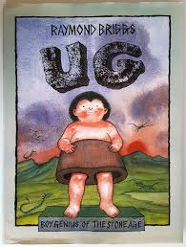  Ug boy genius of the Stone age  Skill – Prediction | 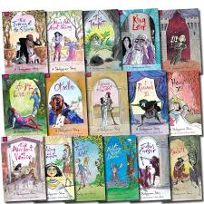  Shakespeare  Skill – Imagining | Preparing a playscript to read aloud  Skill – Questioning  Asking questions to improve understanding of a text  Using dictionaries to check the meaning of words they have read | Inferring characters’ feelings, thoughts and motives  Skill – Summarising  Identifying main ideas and writing a summary | Asking questions to improve understanding of a text  Skill – Effect on the reader  Identifying how language, structure and presentation contribute to meaning
Cross-curricular writing |  | Upcycling and recycling | Archaeological dig | Henry VIII  Battle of Bosworth | Globe Theatre | Rivers – fact file | Vikings

