Year 6 | Autumn 1 | Autumn 2 | Spring 1 | Spring 2 | Summer 1 | Summer 2
Writing Opportunities | Holes – Louis Sachar  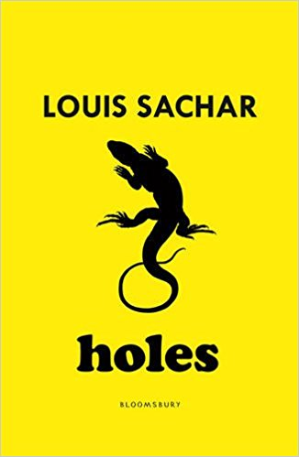  (dangerous story) | Holes – Louis Sachar | 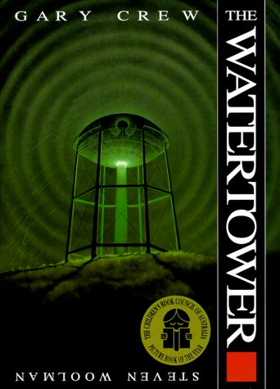  The Watertower – Gary Crew (mystery/suspense) | 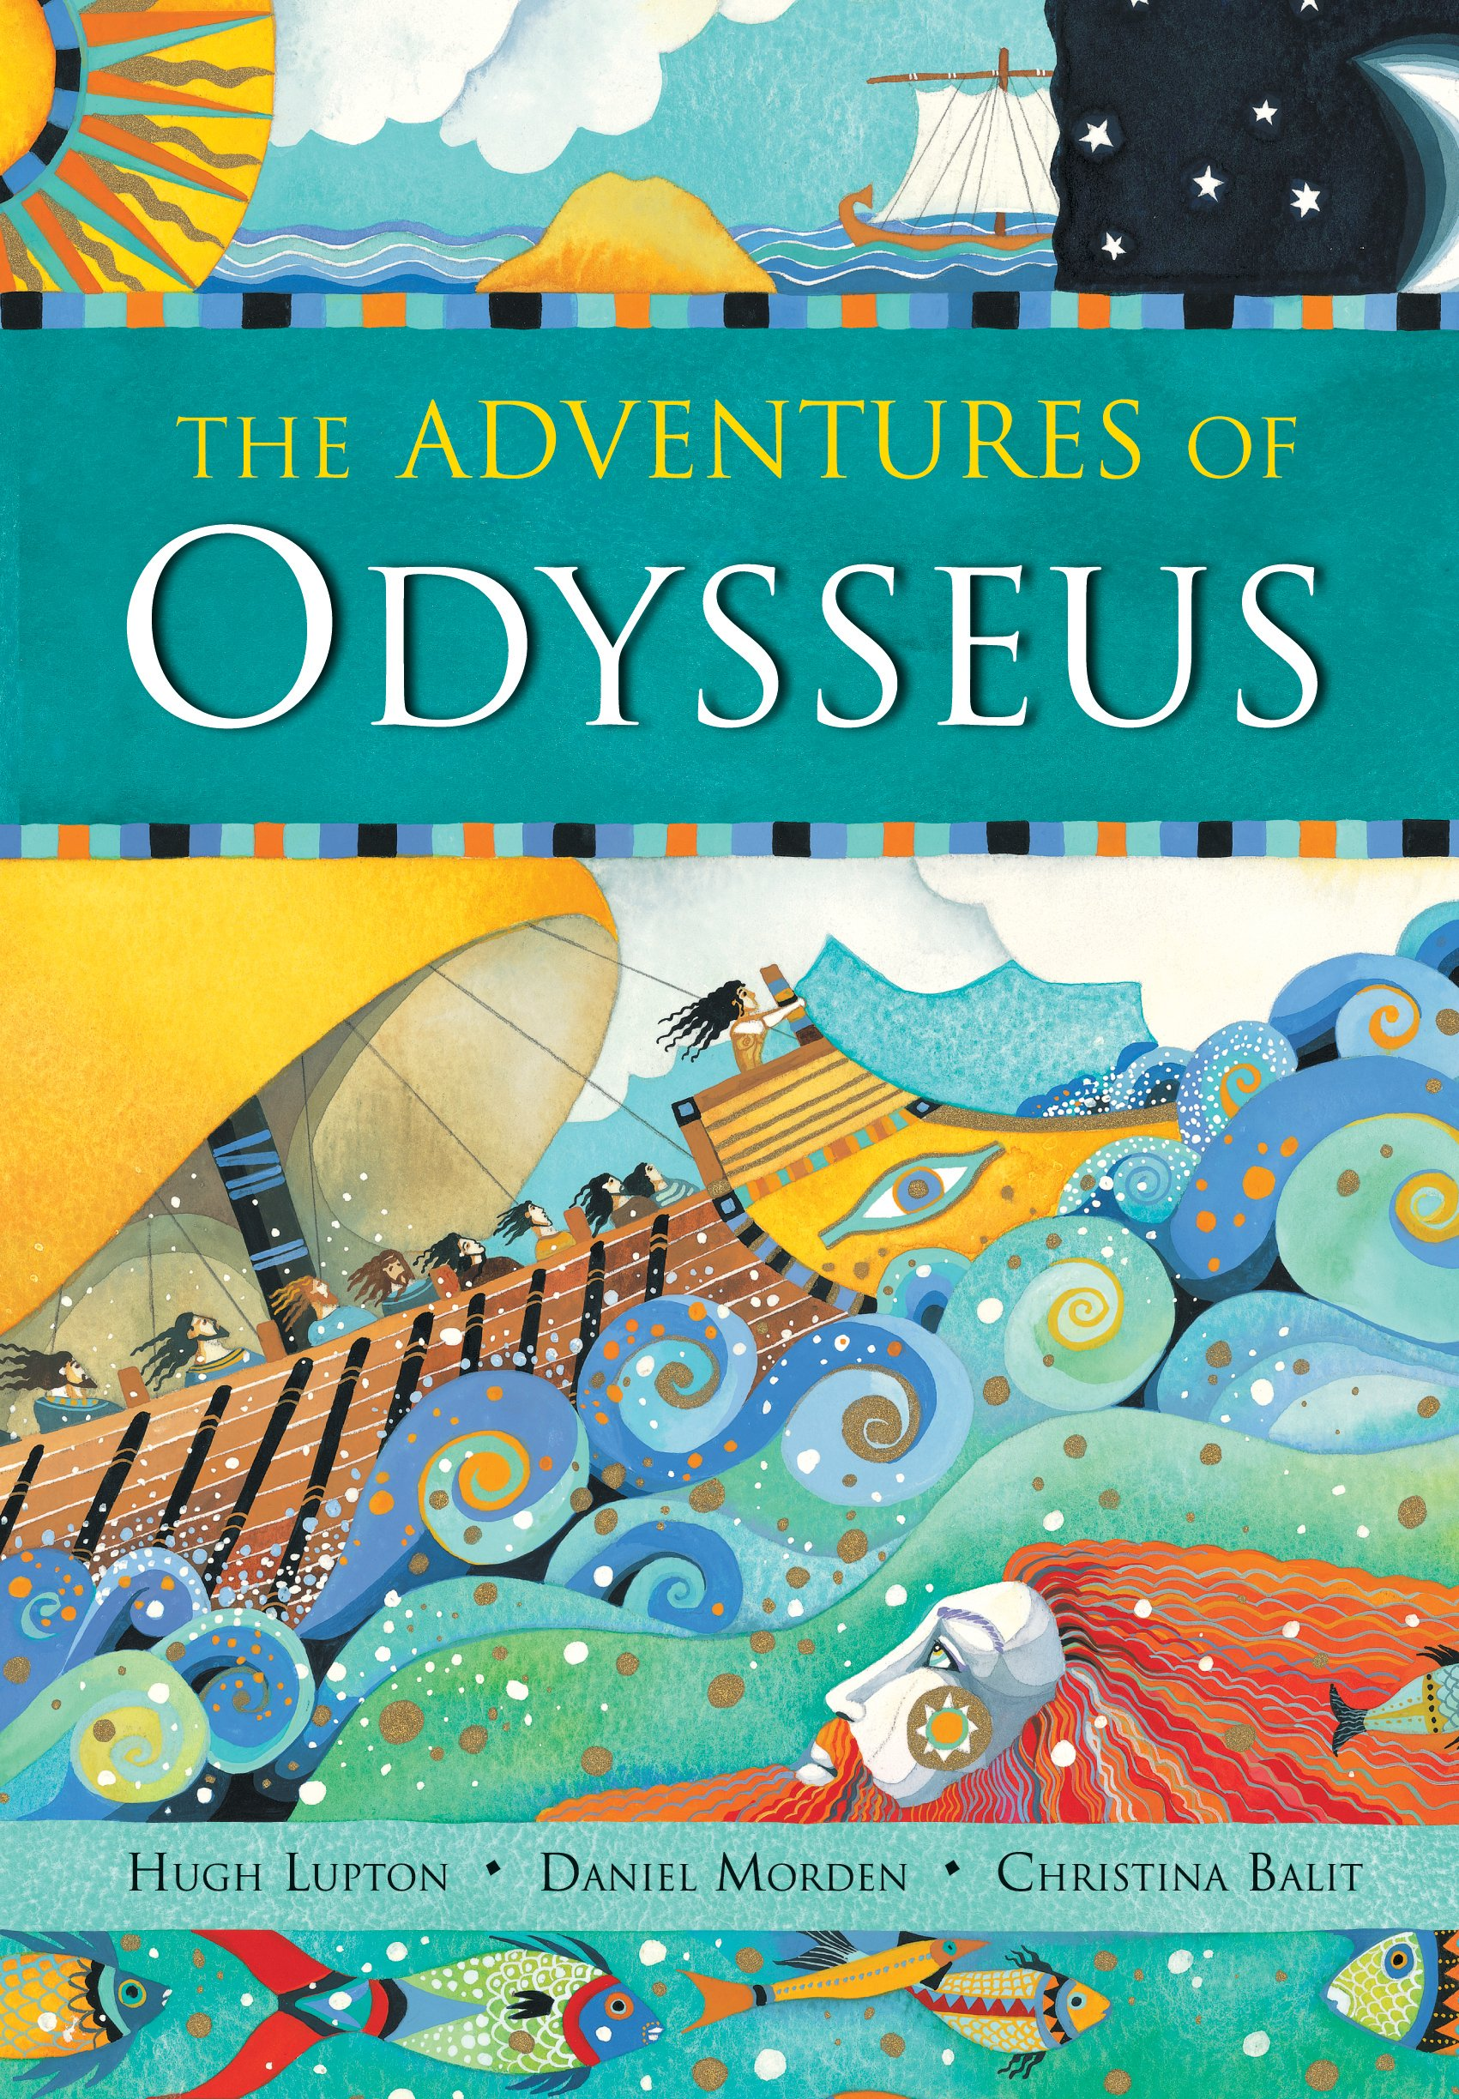  The adventures of Odysseus – Daniel Morden | I am Rosa Parks – Brad Meltzer  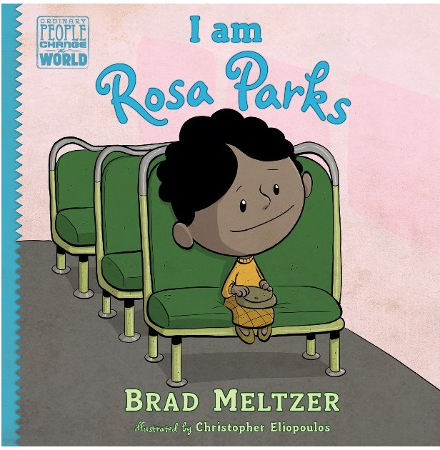 | 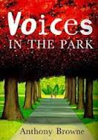  Voices in the park
Writing Opportunities | Poetry – Shanty poems, digging holes | 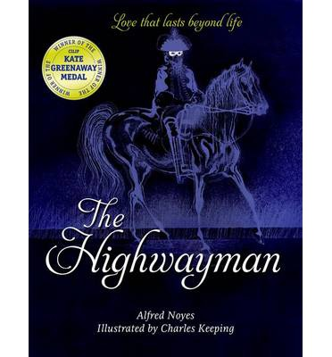  Poetry - The Highwayman – Alfred Noyes | Poetry – Cinquain poem | Poetry – Spine Poem | 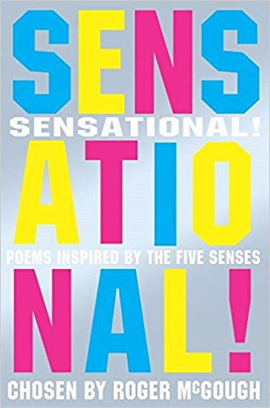  Poetry –  Sensational – Roger McGough | Poetry – Rhyming poetry
Writing Opportunities | Genre:  Report – An inspector’s report on the conditions at Camp Green Lake | Genre:  Explanation text – Yellow spotted lizards | Genre:  Suspense story (change to Bognor) | Genre:  Greek Myths and legends | Genre:  Biography of Rosa Parks | Genre:  Story from another viewpoint
Writing Opportunities | Free write - Letter From Stanley to his mum when he is at the camp | Free write - Newspaper report, Kissing Kate’s treasure has been found | Free write – Report, condition of the pier | Free write – Character profile of a Greek God | Free write – Social impact of the 60’s. | Free write – Persuasive text, why should they be allowed to leave.
Writing Opportunities | Self - initiated | Self-initiated | Self-initiated | Self-initiated | Self-initiated | Self-initiated
Grammar Focus | Using commas to clarify meaning or avoid ambiguity in writing  Using brackets, dashes or commas to indicate parenthesis  Using modal verbs or adverbs to indicate degrees of possibility  Using a wide range of devices to build cohesion within and across paragraphs | Using semi-colons, colons or dashes to mark boundaries between independent clauses  Using a colon to introduce a list Using hyphens to avoid ambiguity  Describing settings, characters and atmosphere and integrating dialogue to convey character and advance the action | Ensuring correct subject and verb agreement when using singular and plural, distinguishing between the language of speech and writing and choosing the appropriate register  Describing settings, characters and atmosphere and integrating dialogue to convey character and advance the action | Use of passive voice to affect the presentation of a sentence  Using hyphens to avoid ambiguity.  Using brackets, dashes or commas to indicate parenthesis using semi-colons, colons or dashes to mark boundaries between independent clauses | Layout devices – such as headings, sub-headings, columns, bullets, tables to structure text.  The difference between subjunctive forms.  The difference between structures typical of informal speech and structures for formal speech  Revision of KS2 – Punctuation and Grammar | Choose language with appropriate level of formality Selecting verb forms for meaning and effect Use adverbs, prepositional phrases and expanded noun phrases To use relative clause
Terminology | Cohesion  Modal verb  Brackets parenthesis | Ambiguity  Hyphen  Semi-colon  Colon | Relative clause  Modal verb  Relative pronoun | Revision of KS2 – Punctuation and Grammar | Subject, object  Active, passive  Synonym, antonym  Ellipsis, hypen, colon, semi-colon, bullet points | KS2 –  Subject, object  Active, passive  Synonym, antonym  Ellipsis, hypen, colon, semi-colon, bullet points
Spelling | Wk 1 -Ambitious Synonyms  Wk 2- Homophones – ce/cy  se/sy  Wk 3 - ant/ancy/ance  Wk 4 - ent/ence/ency  Wk 6 -Prefix with hyphens  Wk 6 - Hyphenated compound adjectives | Wk 1 – able  Wk 2- able  Wk 3 – ably  Wk 4 – word families  Wk 5 – micro and mini | Wk 1 – suffix - fer  Wk 2- ie/ei after c  Wk 3 – ie/ei after c  Wk 4 – word families  Wk 5 – word families  Wk 6 - Statutory challenge words | Wk 1 – End sounds like /shul/  Wk 2- End sounds like /shul/  Wk 3 – soft c spelt ce  Wk 4 - word families  Wk 5 - word families | Wk 1 – words noun and verbs  Wk 2- words noun and verbs  Wk 3 – long /o/ spelt –ou or ow  Wk 4 – end /ible  Wk 5 – end /ibly | Wk 1 – synonyms and antonyms  Wk 2- synonyms and antonyms  Wk 3 - synonyms and antonyms  Wk 4 - synonyms and antonyms  Wk 5 - synonyms and antonyms
Reading Focus | To make predictions  To retrieve information from non-fiction texts To evaluate the author’s use of language  To use appropriate intonation, tone and volume when reciting and reading aloud  To infer from a text | To work out the meaning of words in context  To make predictions about what might happen from details stated and implied  To use appropriate intonation, tone and volume when reciting and reading aloud  To discuss themes and conventions | To work out the meaning of words in context  To summarise  To evaluate the author’s use of language  To determine the meaning of new works, applying morphological knowledge | To recommend books that they have read and give reasons for choices  To evaluate the author’s use of language To determine the meaning of new words | To retrieve information from non-fiction  To make comparisons across books  To work out the meaning of words in context  To distinguish between fact and opinion  To express and discuss understanding of what they read, including through formal presentations and debates, maintaining their own and others ideas and challenging views courteously | To work out the meaning of words in context  To summarise the details and identifying key details that support the main ideas.  To evaluate the author’s use of language  To determine the meaning of new works, applying morphological knowledge
Cross-curricular writing | Topic - Darwin and Evolution | Topic – Journey through our bodies | Topic – Mayans | Topic - Greeks | Topic – The Sixties | Topic – I’m a Year 6 pupil get me out of here

